**NAME- KRISHNA KUMAR MAHTO**

**REG-16BIT0453**

**a.)**

**CODE:**

**Program that calls exec() system call:**

/* This file calls a helloExec file and passes directory path as args that will use directory access commands to access that directory. */

#include<sys/wait.h>

#include<stdio.h>

#include<stdlib.h>

#include<unistd.h> // for fork, stat

#include<sys/types.h> //for closedir,opendir,pid_t

#include<dirent.h> // for opendir,closedir,DIR*

int main(int argc,char **argv)

{

pid_t pid=fork();

int child_status=0;

if(pid==0) // if child process

{

/* child process will ask a brand new process to replace itself. */

printf("I am child process with pid %d and ppid %d, I am going to replace myself with helloExec.\n\n",(int)getpid(),(int)getppid());

char *args[]={"./helloExec","~/OS_Programs",NULL}; //an argument for the new process; as a convention first arg is name of the file to be executed

execvp("./helloExec",args); //passing arg to the new process- helloExec

fprintf(stderr,"execvp failed!\n\n"); //no conditional block is required for fprintf as execvp returns only if it fails

exit(1);

}

else

{

printf("I am parent with pid %d, waiting for child with pid %d to return.\n",(int)getpid(),(int)pid);

}

return 0;

}

**helloExec (called by exec() function call):**

/* This helloExec will access the directory whose address will be passed by the child process */

#include<stdio.h>

#include<stdlib.h>

#include<unistd.h>

#include<sys/types.h> //for opendir,closedir,pid_t

#include<dirent.h> //for opendir,closedir,DIR*

int main(int argc,char *argv[])

{

int i;

puts("I am helloExec!");

printf("Number of parameters: %d\n",argc);

printf("My pid: %d\n",(int)getpid());

for(i=0;i<argc;i++)

printf("My arguments: %s",argv[i]);

DIR* dir_handle=opendir(argv[1]);

struct dirent *dir_entry;

do

{

dir_entry=readdir(dir_handle);

printf("%s\n",dir_entry->d_name);

}while(readdir(dir_handle)!=NULL);

closedir(dir_handle);

return 0;

}

**OUTPUT:**

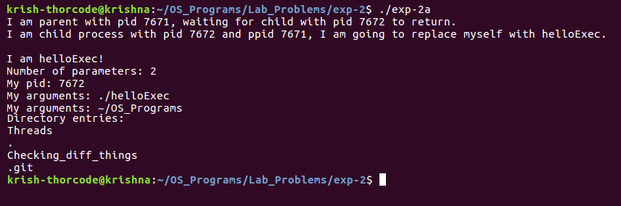

**b.)**

**CODE:**

#include<stdio.h>

#include<unistd.h>

#include<stdlib.h>

#include<sys/types.h>

int main(int c,char **argv)

{

pid_t pid;

pid=fork();

if(pid==0)

{

//child process

printf("I am child and my pid is %d and my parent's pid is: %d\n\n ",getpid(),getppid());

sleep(10); //child goes to sleep

}

else

{

//parent process

printf("I am parent process and my pid is: %d\n",getpid());

/*as the parent will exit in the next line and the child process will still be running the sleep() system call, the child will become orphan.*/

exit(0);

}

return 0;

}

**OUTPUT (opened an empty file and written current date and time):**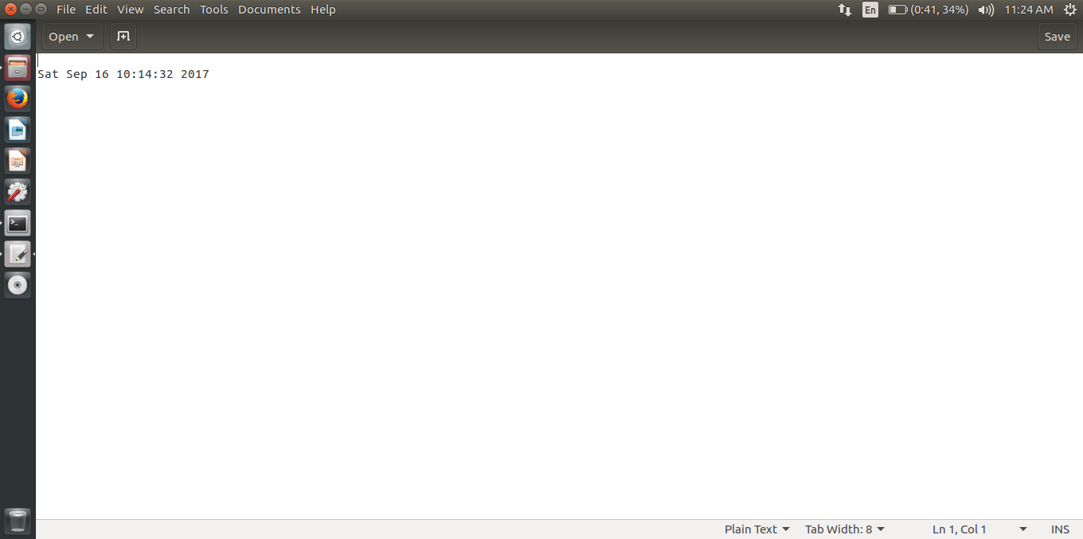

**c.)**

**CODE:**

#include<stdio.h>

#include<unistd.h>

#include<stdlib.h>

#include<sys/types.h>

int main(int c,char **argv)

{

pid_t pid;

pid=fork();

if(pid==0)

{

//child process

printf("I am child and my pid is %d and my parent's pid is: %d\n\n ",getpid(),getppid());

sleep(10); //child goes to sleep

}

else

{

//parent process

printf("I am parent process and my pid is: %d\n",getpid());

/*as the parent will exit in the next line and the child process will still be running the sleep() system call, the child will become orphan.*/

exit(0);

}

return 0;

}

**OUTPUT:**

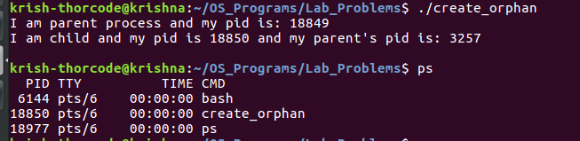

**Child process is still running, parent process has exited.**

**d.)**

**CODE:**

#include<stdio.h>

#include<stdlib.h>

#include<unistd.h>

#include<sys/types.h>

#include<pthread.h>

void *factorial_thread(void *num_recv)

{

int num=*((int*)num_recv);

int *fact=(int*)malloc(sizeof(int));

int i;

*fact=1;

for(i=num;i>1;i--)

(*(fact))*=i;

printf("The factorial is: %d\n",*fact);

return NULL;

}

int main(int argc,char **argv)

{

int n; //number whose factorial will be calculated

static int *r; //result of the factorial's address

pthread_t thread_id;

puts("Enter any number: ");

scanf("%d",&n);

pthread_create(&thread_id,NULL,&factorial_thread,(void*)&n);

pthread_join(thread_id,NULL);

return 0;

}

**OUTPUT:**

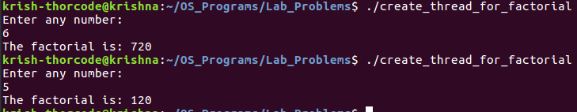

**e.)**

**CODE:**

#include<stdio.h>

#include<unistd.h>

#include<sys/types.h>

#include<stdlib.h>

#include<sys/wait.h>

#include<string.h>

#include<math.h>

int main(int argc,char** argv)

{

if(*(argv+1)[0]=='-')

{

puts("Please enter a positive number and come back.\nExiting...");

exit(1);

}

int count=0,i=0,num=0,n;

if(*(argv+1)[0]!='+')

{

count=strlen(*(argv+1));

for(i=0;i<count;i++)

num+=((*(argv+1)[count-i-1])-48)*pow(10,i);

}

else

{

count=strlen(*(argv+1));

for(i=0;i<count-1;i++)

num+=((*(argv+1)[count-i-1])-48)*pow(10,i);

}

/* it is important to initialise child_status because it's address will be used in wait() in parent process. Until un-initialised, it will have some garbage value. */

n=num;

int child_status=0;

pid_t pid=fork();

if(pid==0) //child process

{

printf("I am child process with pid: %d and ppid: %d\n\n",(int)getpid(),(int)getppid());

puts("The series: ");

for(;n!=1;)

{

if(n%2==0)

{

printf("%d, ",n);

n=n/2;

}

else

{

printf("%d, ",n);

n=(3*n)+1;

}

}

printf("%d\n",n);

return 0;

}

else //parent process

{

printf("I am parent and I am waiting for the child to return, my pid: %d\n",(int)getpid());

wait(&child_status); //waiting for the child to come

puts("My child has come! I too am leaving!!");

}

return 0;

}

**OUTPUT:**

